A School Fight Over Chocolate Milk

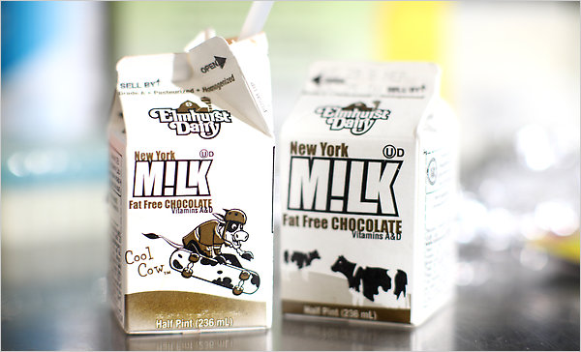

Tony Cenicola/The New York Times

By [KIM SEVERSON](http://topics.nytimes.com/top/reference/timestopics/people/s/kim_severson/index.html?inline=nyt-per)

Published: August 24, 2010

**[](http://www.nytimes.com/?src=vidm)**



MILK, that icon of purity, has been taking some hits lately.



By the time they are 11, children drink more soda than milk. The amount of milk consumed in America over all has fallen to about 20 gallons a year per capita, from 25 gallons in the early 1990s.

It’s even on shaky ground in the one place it has long seemed at home, the school lunchroom. To appease parents whose children can’t or won’t drink milk, a quarter of the nation’s largest school districts now offer rice or soy milk and almost 17 percent of all school districts offer lactose-free milk.

Most recently, [chocolate](http://topics.nytimes.com/top/reference/timestopics/subjects/c/chocolate/index.html?inline=nyt-classifier) milk has emerged as both villain and victim in a cafeteria drama that pits the milk industry, administrators and parents against one another.

For those who haven’t been in a school cafeteria lately, 71 percent of the milk served nationwide is flavored. In New York City, school food officials say fat-free chocolate milk fills nearly 60 percent of the 100 million cartons served each year. The rest is one-percent plain.

But chocolate milk can contain about twice as much sugar as plain low-fat milk. Milk is naturally sweet from lactose; flavored milk also contains cane sugar or high-fructose corn syrup, making it unwelcome in some cafeterias.

When students went back to school Monday in the District of Columbia, they were served only low-fat white milk. Berkeley, Calif., schools banned chocolate milk, and Florida school officials are considering it.

“There’s been a lot of pressure on flavored milk recently,” said Diane Pratt-Heavner of the [School Nutrition Association](http://www.schoolnutrition.org/).

Flavoring milk, some school officials and milk processors say, is the only way to get students to drink it. Milk provides a host of nutrients, including calcium, protein and vitamin D, which recent studies show is deficient in about three-quarters of teenagers and adults.

“It’s better for them to have some milk with some flavoring and a little added sugar than to go without milk,” said Ms. Pratt-Heavner, whose organization last month helped release a study that showed that elementary school children drank 35 percent less milk at school on average when flavored milk was removed.

The study, based on seven school districts, was paid for by the Milk Processor Education Program, a dairy industry group that supports the “Got Milk?” campaign, and conducted by Prime Consulting Group, whose clients include several large food companies.

Milk processors began a $500,000 [campaign](http://www.raiseyourhand4milk.com/) a year ago to defend chocolate milk from what they called “food activists” who believe it delivers too much added sugar. There is a lot at stake. The milk sold in schools accounts for 7 percent of all milk sales in the country.

The campaign has picked up in time for this school year. Posters featuring professional athletes promoting milk and chocolate milk for student athletes are ready for shipping to schools, and on Wednesday, the School Nutrition Association is offering its members a “Webinar” entitled “Keep flavored milk from dropping out of school.”

Dairy processors and some nutritionists are concerned that important nutrients are going down the drain instead of into children, said Ann Marie Krautheim, senior vice president for nutrition affairs at the National Dairy Council. “There is a vocal minority that is looking at flavored milk from one sole angle, which is the sugar content,” she said. “Parents need to consider the total nutrient package.”

People trying to make school lunch more nutritious say it’s outrageous to serve an eight-ounce drink that can contain more than five teaspoons of sugar — almost as much as a cup of soda or apple juice — and call it healthy.

“Saying we need to add sugar and flavoring to milk to get kids to drink it is like saying we need to feed kids apple pie if they don’t like apples,” said Ann Cooper, who runs the Boulder, Colo., school food program and a national Web site, [chefann.com](http://chefann.com/), aimed at reforming school lunch.

She’s not opposed to chocolate milk, but she is opposed to teaching children it is part of a healthy daily diet.